ITUE203: WEB DEVELOPMENT FRAMEWORKS 25CS106– Yana


Faculty of Technology and Engineering

Chandubhai S. Patel Institute of Technology (CSPIT) Department of Computer Science & Engineering

Laboratory manual
Academic Year | : | 2026-27 | Semester | : | 3rd

Practical - 13

PROBLEM STATEMENT :

Create simple PHP JSON API endpoints for events or students and consume them using Fetch API. Perform list, add, update, and delete operations asynchronously without full page reload.

OBJECTIVE:
To develop simple PHP-based JSON API endpoints for managing events or student records and consume them using the Fetch API to perform asynchronous CRUD operations (Create, Read, Update, and Delete) without reloading the entire webpage.

OUTPUT:

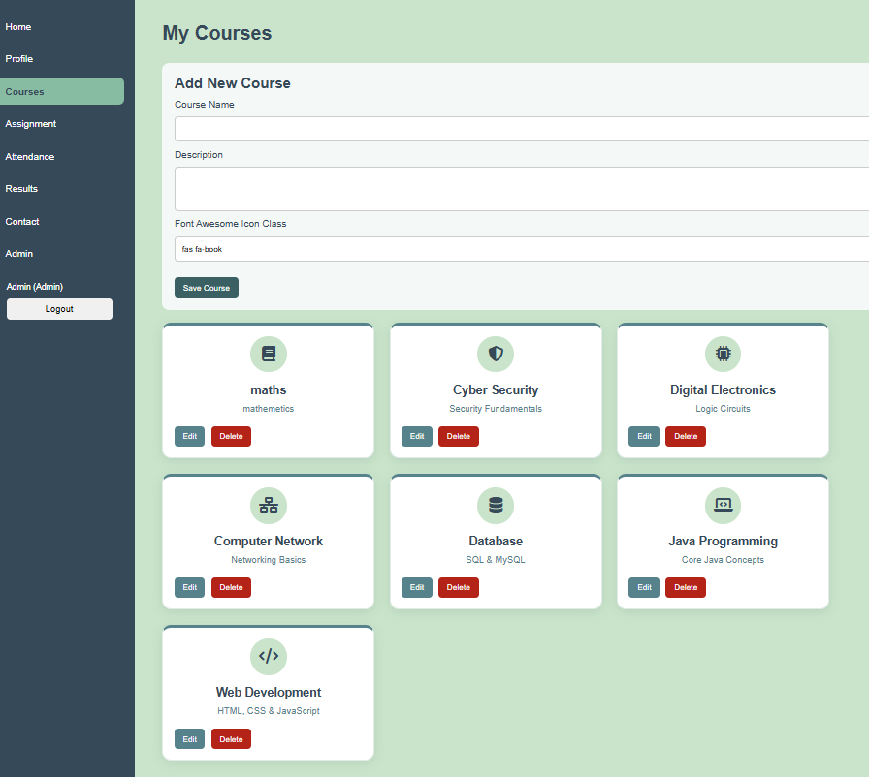
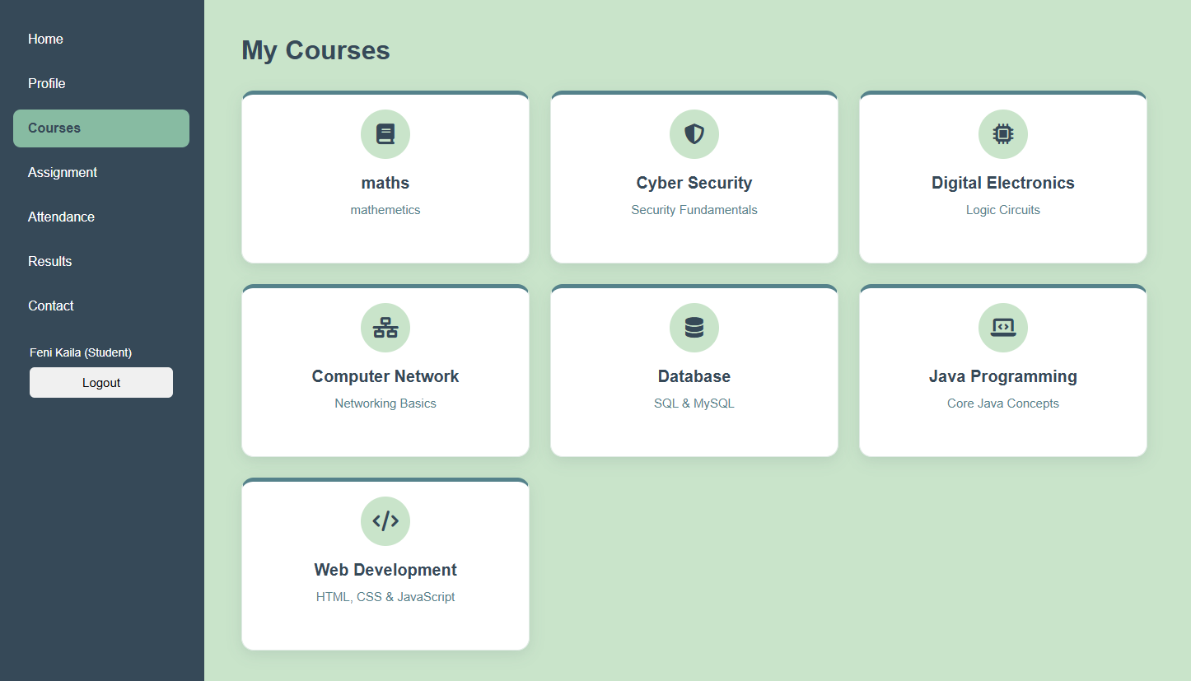
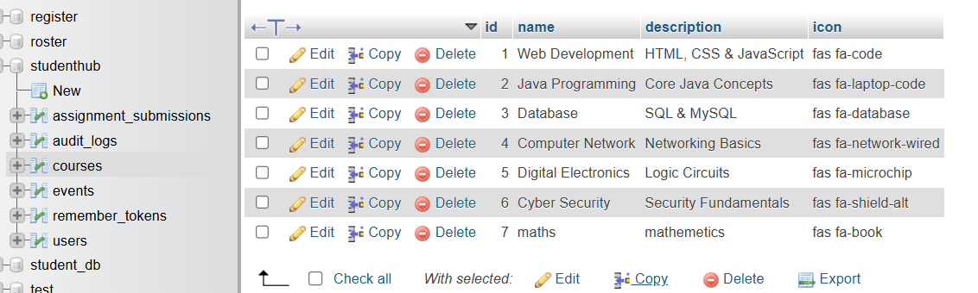

LEARNING OUTCOME:
• Understand the fundamentals of RESTful APIs and JSON data exchange using PHP.
• Create PHP API endpoints to retrieve, add, update, and delete student or event records.
• Use the JavaScript Fetch API to send asynchronous HTTP requests and process JSON responses.
• Implement CRUD operations dynamically without a full page reload.
• Handle API responses, errors, and user feedback effectively.

